# Business Intelligence Billability Report

## Introduction

In this report we perform queries in MS SQL Server database answering to some Business Intelligence issues. Also, we provide complete solution and reporting based in the below SQL queries with the Power BI reporting tool.

**Part B:**

Develop three SQL queries to answer the following questions:

1. How many unbillable hours were recorded per month for the current year?

We perform the below query making a count of recordedtimehours also we make filtering with the column billable = 'Unbillable'. Also, we make the necessary joins and we group by with calendarmonthname and calendaryear;

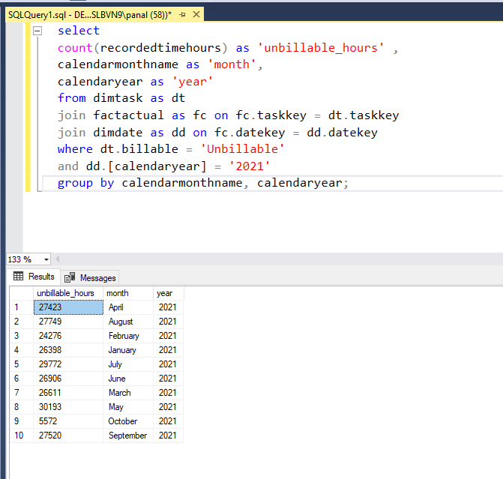

1. What is the Year-To-Date recorded billable hours per customer for each month?

(Year-To-Date hours for each month = the total hours from the start of the year until the end of each month).

In this query we answering to the question making a sum to the billable_hours column and we make an over ordering by with the columns end_of_month and customer.

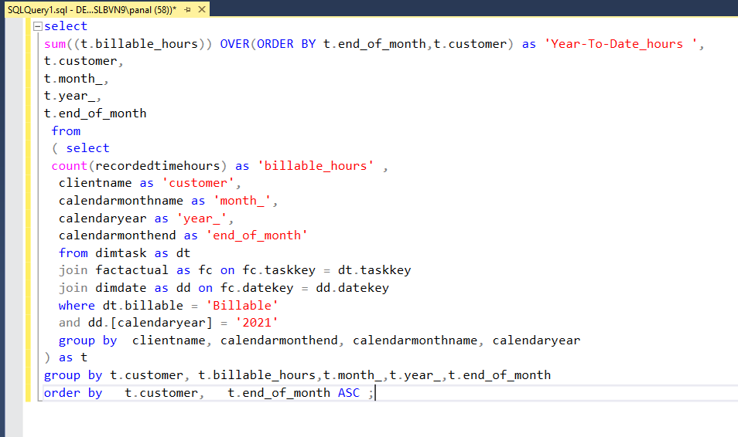

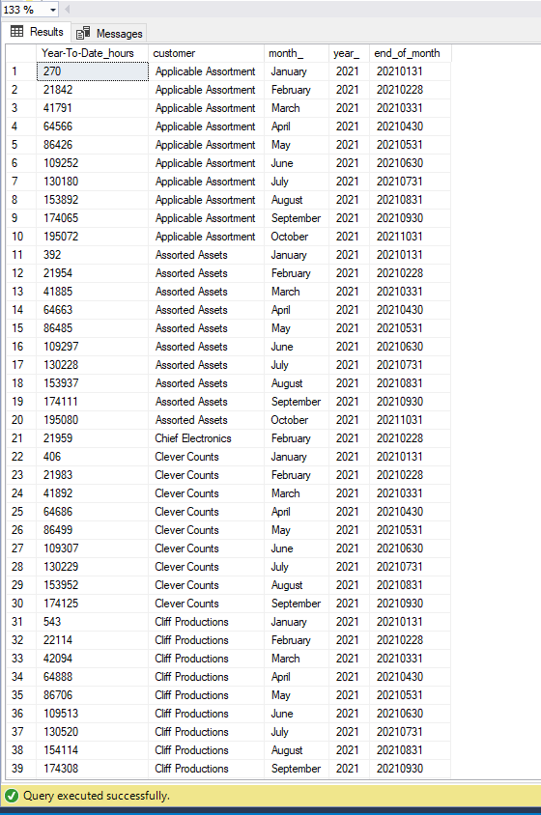

1. Which is the percentage of billable recorded hours over total recorded hours (both billable and unbillable) for each month for teams “Wise Kingfishers” and “Big Beasts”?

In the below solution we make a query which calculates percentage of billable recorded hours over total recorded hours. Also, we filter the results specific for the teams “Wise Kingfishers” and “Big Beasts”.

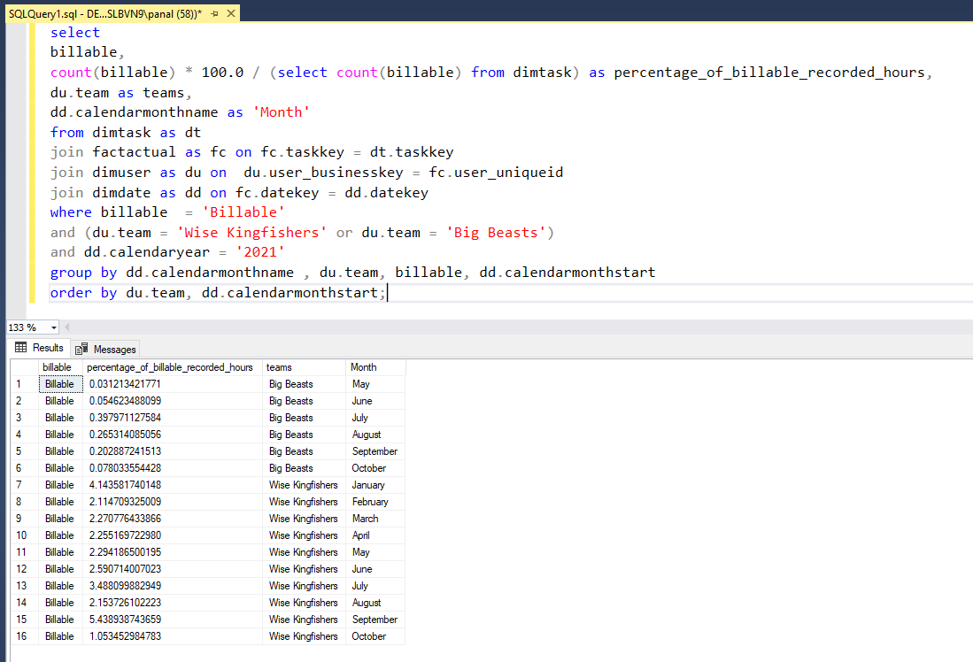

**Part C:**

The final goal of the assignment is to create a “Billability Report” in a reporting tool of your choice that contains graphs that cover your answers in part B. You can choose any type and format of graphs at your disposal.

* + - 1. **Unbillable hours recorded per month report**

In the below report we visualize the 1st query of our solution. We can see easily and interactively the number of unbillable hours per month and also, we can see an average about the unbillable hours.

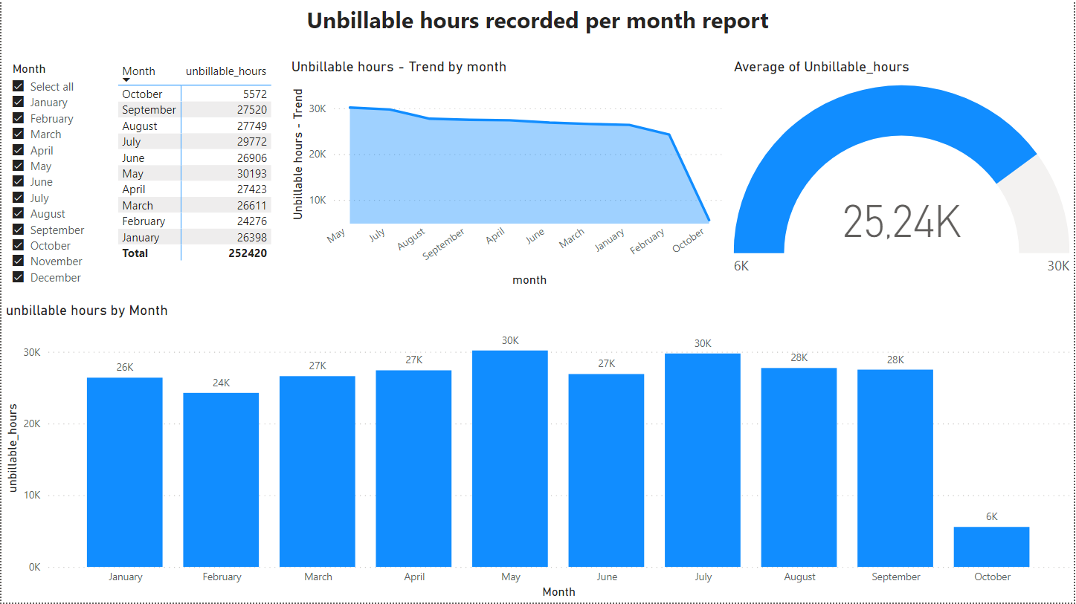

* + - 1. **Year-To-Date recorded billable hours per customer for each month report**

In this report we are able to see the Year-To-Date recorded billable hours per customer for each month report. We can visualise a report for each month and customer making the appropriate selections with our filters.

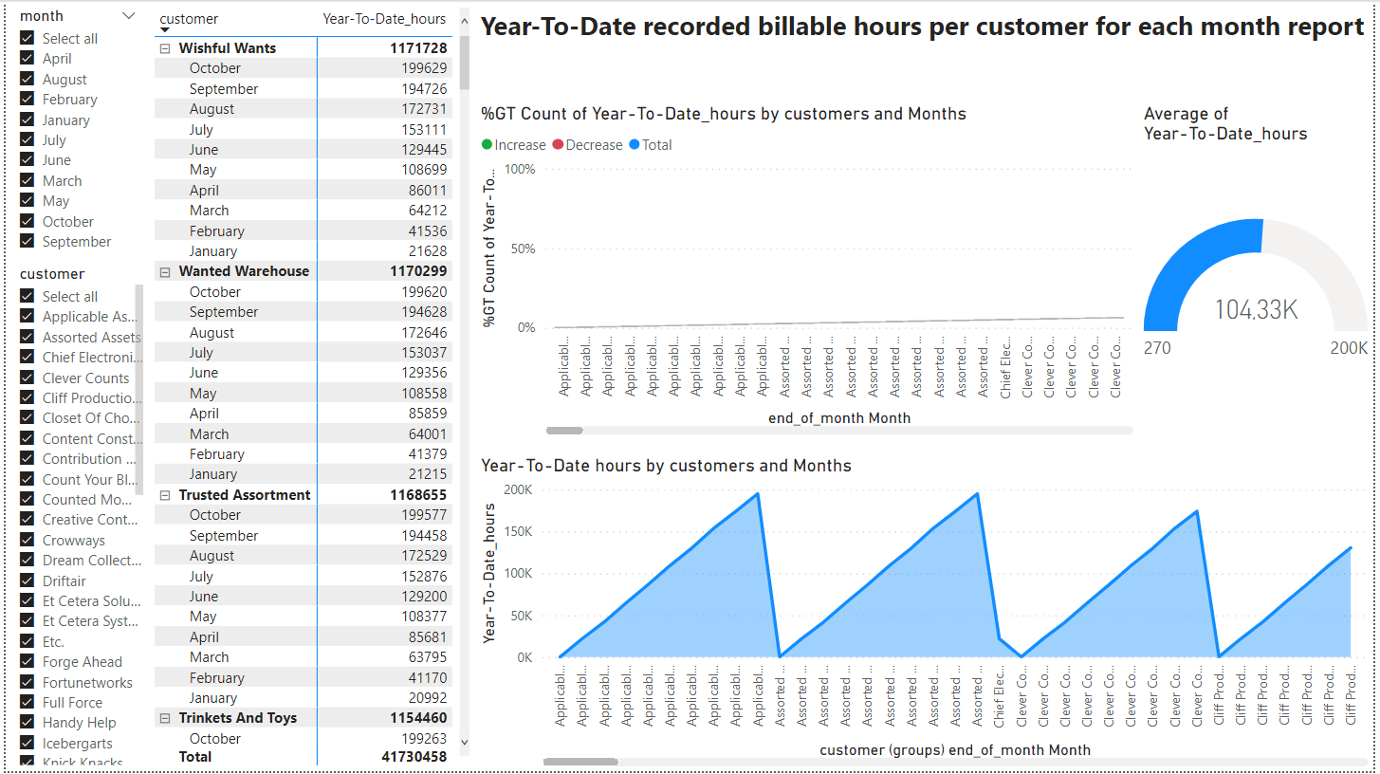

* + - 1. **Percentage of billable recorded hours over total recorded hours for each month for teams “Wise Kingfishers” and “Big Beasts” report**

Finally, in the below report we make visualization the 3rd query and as we can see make a complete report for the billable recorded hours and specific for the teams “Wise Kingfishers” and “Big Beasts”.

